**JOB APPLICATION TRACKING SYSTEM**

1 INTRODUCTION

## Overview

The applicant tracking system (ATS) makes it simple for recruiters and hiring managers to track job seekers through all stages of the hiring process, from the first application to the actual job offer. The applicant tracking system (ATS) compiles and evaluates resumes and job application materials. The information is then organised into a searchable database, which enables recruiters to easily find and classify possible candidates in accordance with a range of requirements and job specifications.

## Purpose

→ Centralizing candidate information

→ Managing job postings

→ Tracking application status

→ Streamlining communication

→ Improving collaboration

1. Problem Definition & Design Thinking

## Empathy Map

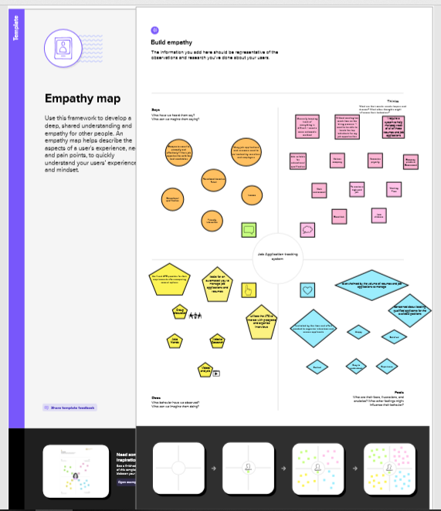

## Ideation & Brainstorming Map

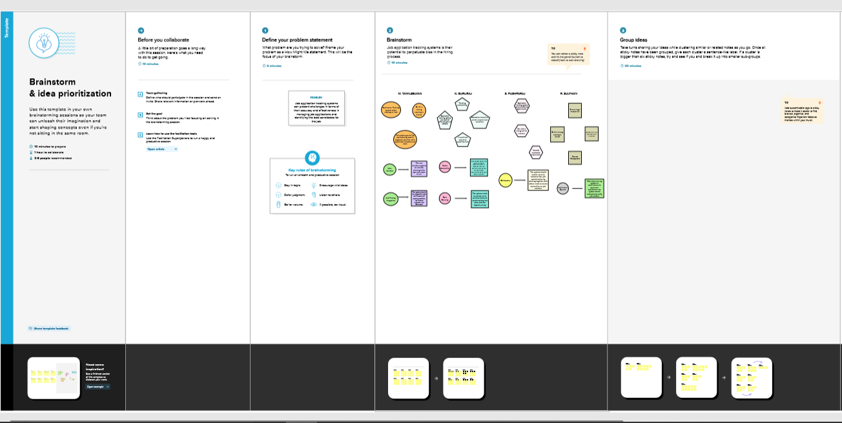

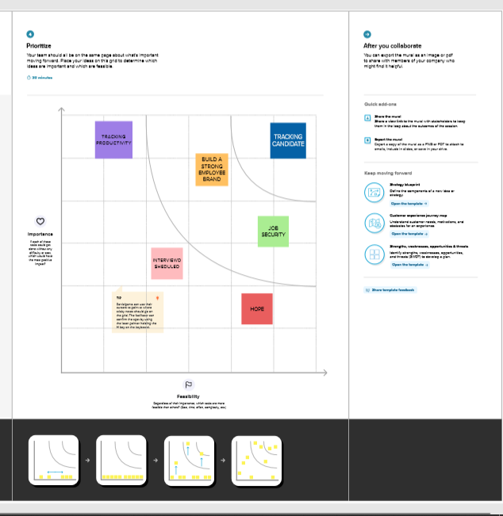

1. RESULT

## Data Model:

|  |  |  |
| --- | --- | --- |
| Object Name | Field Name | Data Type |
| Object 1 RECRUITER | Job title | Text |
| Object 2 JOBS | DescriptionLocation | Text areaText |
| Object 3 CANDIDATE | Candidate nameCandidate number | TextAuto number |
| Object 4 JOB APPLICATION | Job IDJob Application Number | NumberAuto number |

## Activity & Screenshot

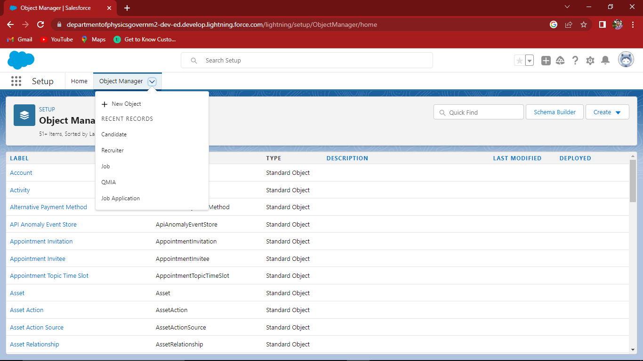

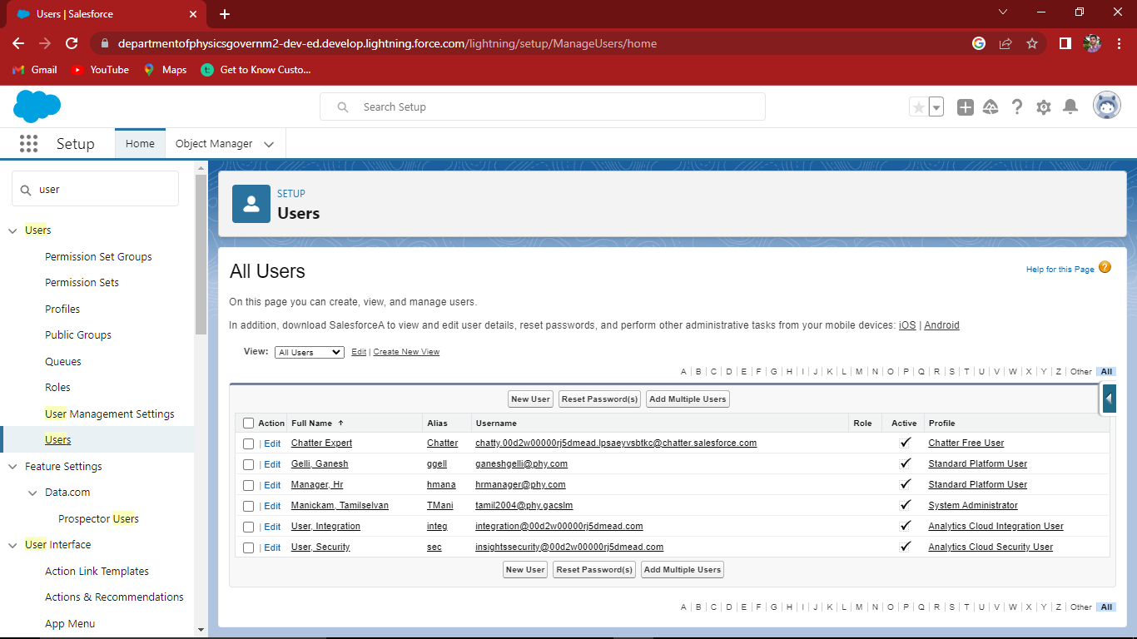

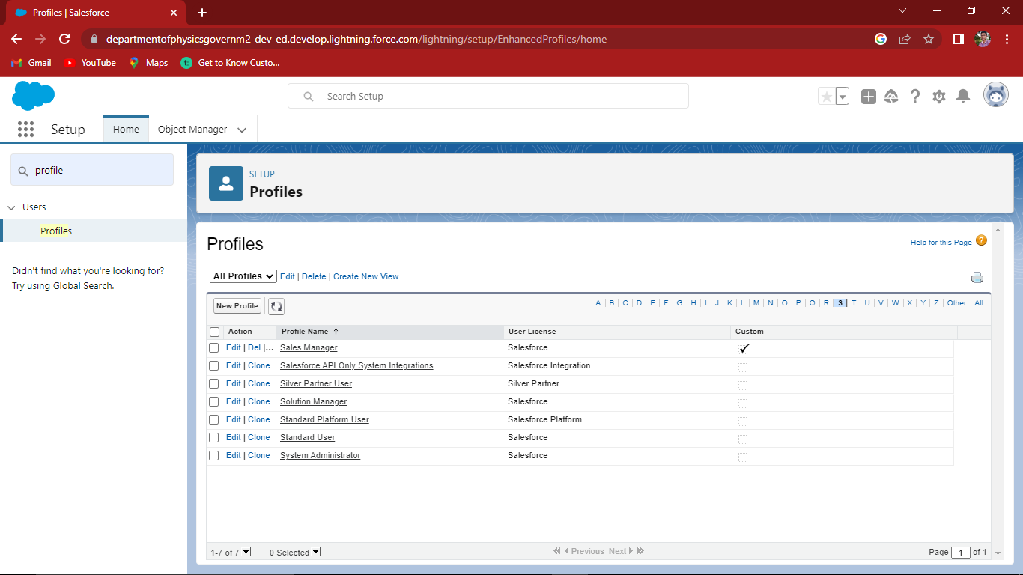

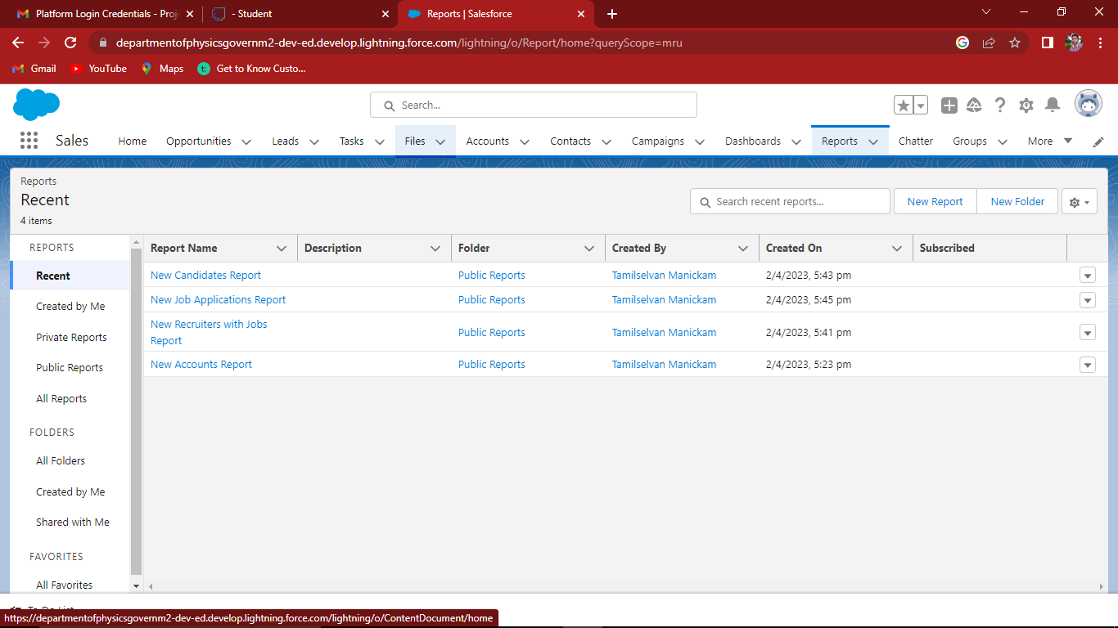

1. Trailhead Profile Public URL

Team Lead - <https://trailblazer.me/id/mselvan77>

Team Member 1 - <https://trailblazer.me/id/guru2003>

Team Member 2 – <https://trailblazer.me/id/pyash29>

Team Member 3 – <https://trailblazer.me/id/sultr1>

1. ADVANTAGES & DISADVANTAGE

Advantages:

◊ Simplifies application process

◊ Provides real-time application status

◊ Increases visibility

◊ Saves time

◊ Improves candidate experience

◊ Enhances collaboration

◊ Improves data analysis

Disadvantages:

* Can be impersonal

* May not catch all relevant information

* Requires investment

* Could limit candidate pool

* Could create bias

* Potential for technical glitches

1. APPLICATIONS

Candidate management: The ATS tracks the status of job applications and manages candidate information, allowing recruiters and hiring managers to easily search and organize candidate profiles

Reporting and analytics: The ATS generates reports and analytics that allow employers to track the effectiveness of their recruitment strategies and identify areas for improvement

Compliance management: The ATS ensures that the recruitment process is compliant with relevant laws and regulations, such as equal opportunity employment laws and data privacy regulations

1. CONCLUSION

#### job application tracking systems have become an essential tool for modern recruiters and job seekers. These systems allow for the efficient and streamlined management of the recruitment process, from initial application screening to final hiring decisions.

# 8 FUTURE SCOPE :

#### Artificial intelligence (AI): AI and machine learning technology can help automate the hiring process even more by identifying the top candidates, evaluating applicant fit, and even conducting preliminary interviews.

#### Mobile integration: As more job seekers use mobile devices to search and apply for jobs, job application tracking systems will need to be optimized for mobile devices and provide a seamless mobile user experience.

#### Personalised and engaging applicant experience: Job application tracking systems will need to offer features like personalised job suggestions, chatbots, and virtual interviews in order to attract and keep top talent.

#### Better data analysis: Job application tracking systems will continue to evolve to provide more sophisticated data analysis and reporting, allowing recruiters to make more informed decisions about their recruitment strategy and candidate pool.

#### Integration with other HR tools: To provide a more comprehensive perspective of the complete employee lifecycle, job application tracking systems will need to link more fluidly with other HR resources, such as HR information systems, talent management systems, and performance management systems.